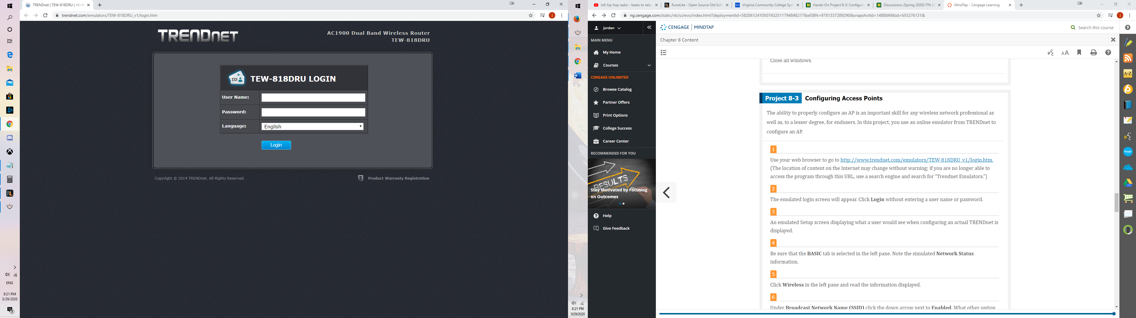

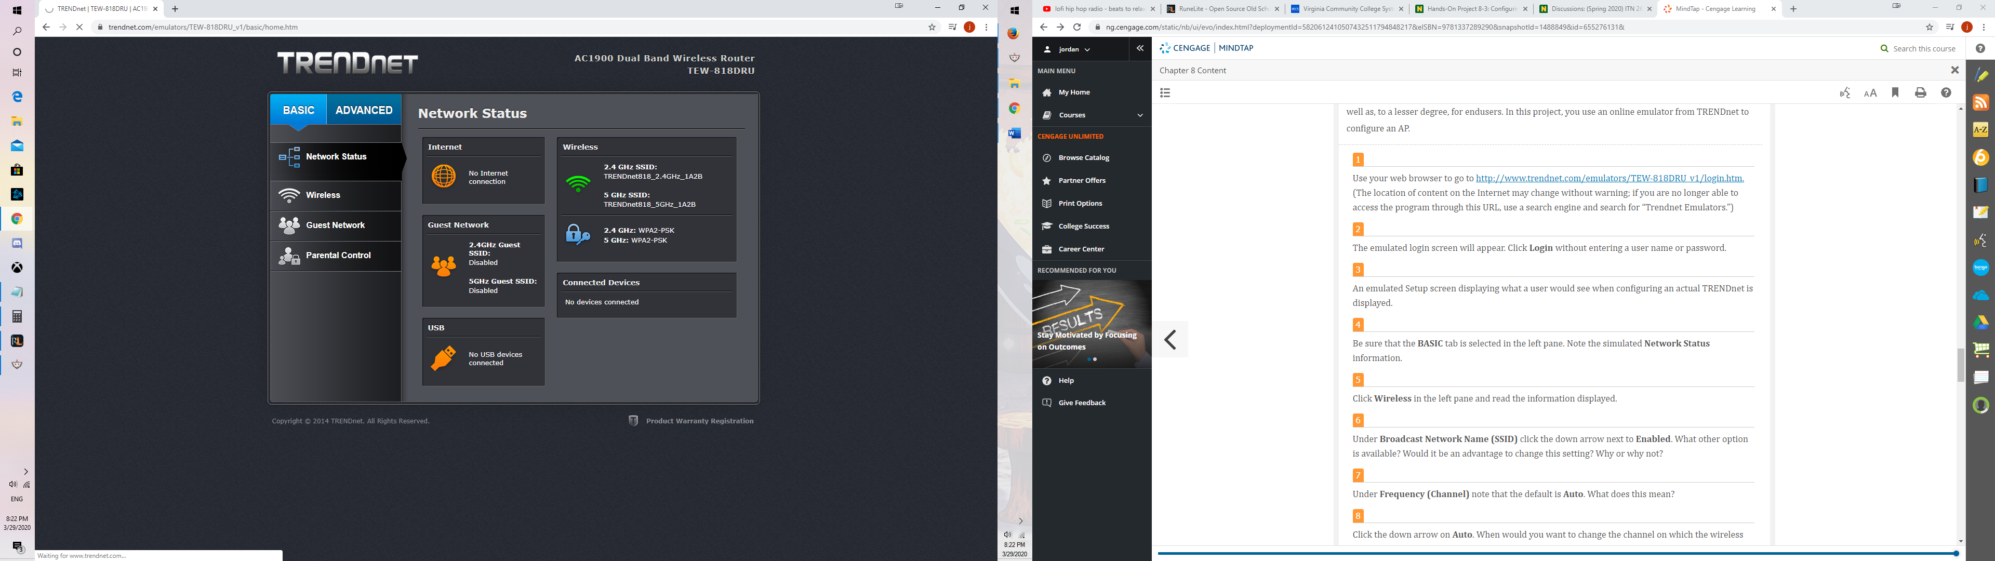

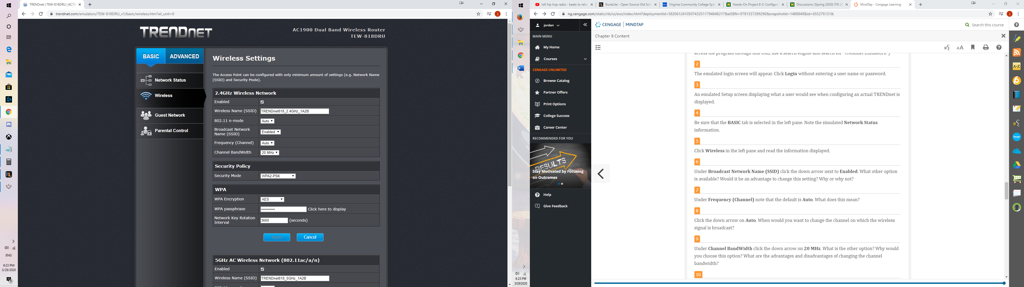

Broadcast Network dropdown is either Enabled or disabled. If you disable it, then it would make your Wi-Fi network name invisible to other users. It only hides the name, not the network itself. So the advantage would be hiding your name and there’s no real disadvantage to this in my opinion.

If your neighbor's network slow down your home network and internet connection, change the wireless channel on your router so that it communicates on a different frequency to avoid interference.

If you set the channel to 40 MHz, it will allow you to use 2/3 of the entire Wi-Fi band. Basically, having a higher chance of overlapping and interfering with other wireless networks. Meanwhile, if you set the channel width to 20 MHz, the network will only overlap with the two channels before and after that frequency.

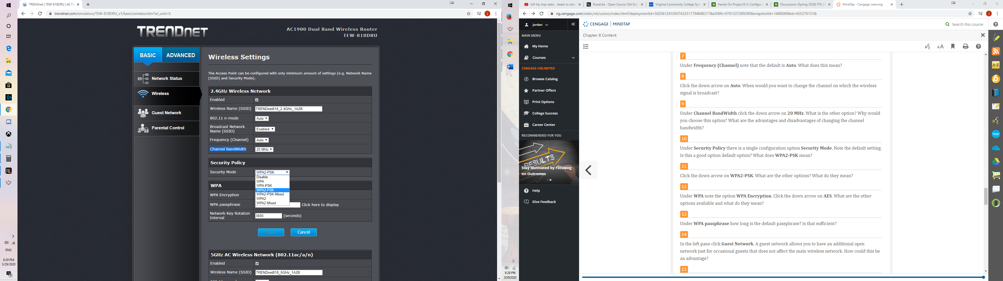

 WPA2-PSK is a method of securing your network using WPA2 with the use of the optional Pre-Shared Key (PSK) authentication, which was designed for home users without an enterprise authentication server. Its standard default option that is fine.

WPA was used to fix the weakness of WEP. The encryption key used by WPA is a passphrase. Most of the information used to create this key is mostly known, so the hacker has to just guess the passphrase to have access to the network. WPA2 has two encryption algorithms: AES and TKIP.

The default passphrase is 12 characters. I don’t think it’s enough. I think 16 is a lot better.

It could be an advantage to have a guest network because of the security it offers. You can control who has access to your network.

Its not enabled by default because I don’t want my guest accessing my private LAN network.

Basic Client Isolation is enabled by default when the SSID is configured for NAT mode and cannot be disabled. Devices outside of the wireless network cannot initiate a connection to a wireless client.

It’s a guest network. It wouldn’t make sense to have a password for guests and if you enabled it that would mean they would need a password to access the network.

Yes it would provide strong security because it would be blocking ports.

It was very useful and easy to navigate this user interface and it provided plenty if not more information than needed to set up the settings on a security system.

My key take way from this was seeing how easy it is to set up my security system and change it how I would like. Also, I learned the benefits from setting up a guest network and how helpful it is. Lastly changing the frequency if you’re constantly having network issues because all your neighbors are on the same frequency could be a pain but now knowing that I can switch it so easily helps a lot.